Arexis
Genetic Database Tool

Functional Specification

Version 7

Prevas AB

Contents

1 Introduction 6
1.1 General 6
1.2 Overview 6
2 Platform 7
2.1 Hardware 7
2.2 Software 7
2.3 Security 7
2.4 Scalability 8
3 Information structure 9
3.1 Part model 1: Projects and Users 9
3.1.1 Project 9
3.1.2 User 10
3.1.3 Role 10
3.1.4 Privilege 10
3.2 Part model 2: Species 11
3.2.1 Species 11
3.2.2 Chromosome 12
3.2.3 L-Marker 12
3.2.4 L-Allele 12
3.3 Part model 3: Sampling Units 13
3.3.1 Sampling Unit 13
3.3.2 Individual 14
3.3.3 Grouping 14
3.3.4 Group 14
3.3.5 Sample 15
3.4 Part model 4: Phenotypes 16
3.4.1 Variable 16
3.4.2 Variable Set 17
3.4.3 Phenotype 17
3.4.4 U-Variable 17
3.4.5 U-Variable Set 18
3.5 Part model 5: Genotypes 19
3.5.1 Marker 20
3.5.2 Allele 20
3.5.3 Genotype 20
3.5.4 Marker Set 21
3.5.5 Position 21
3.5.6 U-Marker 21
3.5.7 U-Allele 22
3.5.8 Unified Marker Set 22
3.5.9 U-Position 22
3.6 Part model 6: Analyses 23
3.6.1 File Generation 23
3.6.2 Data File 24
3.6.3 Filter 24
4 User interface 25
4.1 Login Procedure 25
4.2 Normal User Functionality 25
4.2.1 Project Administration 25
4.2.1.1 Set Project 25
4.2.1.2 List Project Members 26
4.2.1.3 Project Statistics 26
4.2.1.4 List Roles 26
4.2.1.5 Import Role 27
4.2.1.6 Session Options 27
4.2.2 Sampling Unit Administration 27
4.2.2.1 List Sampling Units 27
4.2.2.2 List Groupings 27
4.2.2.3 Import Groupings 27
4.2.2.4 List Groups 27
4.2.2.5 Group Membership 27
4.2.2.6 List Individuals 27
4.2.2.7 Import Individuals 27
4.2.2.8 List Samples 27
4.2.2.9 Import Samples 27
4.2.3 Phenotype Administration 27
4.2.3.1 List Variables 27
4.2.3.2 Import Variables 27
4.2.3.3 List Variable Sets 27
4.2.3.4 Variable Set Membership 27
4.2.3.5 Import Variable Sets 27
4.2.3.6 List U-Variables 27
4.2.3.7 Map U-Variables 27
4.2.3.8 Import U-Variables 27
4.2.3.9 Import U-Variable mappings 27
4.2.3.10 List U-Variable Sets 27
4.2.3.11 U-Variable Set Membership 27
4.2.3.12 Import U-Variable Sets 27
4.2.3.13 List Phenotypes 27
4.2.3.14 Import Phenotypes 27
4.2.3.15 Phenotype Status 27
4.2.4 Genotype Administration 27
4.2.4.1 List Markers 27
4.2.4.2 Import Markers 27
4.2.4.3 Import Library Markers 27
4.2.4.4 List Marker Sets 27
4.2.4.5 Marker Set Membership 27
4.2.4.6 Marker Set Positions 27
4.2.4.7 Import Marker Sets 27
4.2.4.8 List U-Markers 27
4.2.4.9 Map U-Markers 27
4.2.4.10 Import U-Markers 27
4.2.4.11 Import U-Marker mappings 27
4.2.4.12 List U-Marker Sets 27
4.2.4.13 U-Marker Set Membership 27
4.2.4.14 U-Marker Set Positions 27
4.2.4.15 Import U-Marker Sets 27
4.2.4.16 List Genotypes 27
4.2.4.17 Update Level for a Set of Genotypes 27
4.2.4.18 Import Genotypes 27
4.2.4.19 Genotype Status 27
4.2.4.20 Inheritance Check 27
4.2.5 Analyses Administration 27
4.2.5.1 List Filters 27
4.2.5.2 List File Generations 27
4.2.5.3 Start File Generation 27
4.3 System Administrator Functionality 27
4.3.1 Project Administration 27
4.3.1.1 Edit Projects 27
4.3.1.2 Project Statistics 27
4.3.1.3 List Users 27
4.3.2 Species Administration 27
4.3.2.1 List Species 27
4.3.2.2 List L-Markers 27
4.3.2.3 Import L-Markers 27
4.3.2.4 Import Project Markers 27
4.4 Genetic Query Language - GQL 27
4.5 User Privileges 27
4.5.1 General Privileges 27
4.5.2 Sampling Unit Privileges 27
4.5.3 Phenotype Privileges 27
4.5.4 Genotype Privileges 27
4.5.5 Analysis Privileges 27
5 File formats 27
5.1 Sampling Unit Files 27
5.1.1 Individual File 27
5.1.2 Grouping File 27
5.1.3 Sample File 27
5.2 Genotype Files 27
5.2.1 Marker File 27
5.2.2 Marker Set File 27
5.2.3 Genotype List File 27
5.2.4 Genotype Matrix File 27
5.2.5 Unified Marker Mapping File 27
5.3 Phenotype Files 27
5.3.1 Variable File 27
5.3.2 Variable Set File 27
5.3.3 Phenotype List File 27
5.3.4 Phenotype Matrix File 27
5.3.5 Unified Variable Mapping File 27
5.4 Analysis Files 27
5.4.1 General Table Format 27
5.4.1.1 Data.txt 27
5.4.1.2 Log.txt 27
5.4.2 LINKAGE input format 27
5.4.2.1 Data.txt 27
5.4.2.2 Pedigree.txt 27
5.4.2.3 Pedigree_makeped.txt 27
5.4.2.4 Mapping.txt 27
5.4.2.5 Log.txt 27
5.4.3 CRIMAP input format 27
5.4.3.1 Chr<n>.gen 27
5.4.3.2 Mapping.txt 27
5.4.3.3 Log.txt 27
5.4.4 MAPMAKER input format 27
5.4.4.1 Gen_prep.txt 27
5.4.4.2 Gen_raw.txt 27
5.4.4.3 Log.txt 27
5.5 Species Files 27
5.5.1 Chromosome File 27
5.6 Project Files 27
5.6.1 Role File 27
6 Document Versions 27

Introduction

General
This document describes the structure and functionality of a system supporting research groups, working with the problem of finding and isolating genes.

The overall goals of the system is:

- Minimize the amount of time-consuming routine tasks
- Reduce the number of error sources
- Define a flexible and powerful information structure

Overview
The system database includes the following five information areas:
- Species, e.g. species and chromosomes
- Sampling Units, e.g. sampling units and individuals
- Phenotypes, e.g. variables and phenotypes
- Genotypes, e.g. markers and genotypes
- Analyses, e.g. filters and data files

The system offers the following functionality:

- Import, storage and verification of structures of individuals
- Import, storage and verification of phenotype and genotype data
- Keeping of a history of data changes for most objects
- Automatic generation of input files for analysis programs, e.g. LINKAGE
- Multi-user system with access control
- Multiple projects with local data

The system is multi-user and based on modern web technology. It runs in an intranet on the most common operating systems, e.g. Unix, Windows and Mac.

The system is constructed as a one installation non-distributed system and multiple installations cannot share information in an automatic way.

The system is built around the following components:
- A standard, but powerful, personal computer with Linux
- An Oracle relational database system
- An Apache web server running Java servlets

Platform

Hardware
The system is built as a server-client system, where the server hardware is a standard PC and the client hardware can be any computer running a web browser.

Software
The server operating system is Linux, although the system can be changed to run on Windows NT with a small amount of work.

An Oracle 8 relational database system is used for data storage and retrieval.

An Apache web server, running Java servlets, produces the web pages which makes up the system user interface.

Although the system supports both Microsoft Internet Explorer and Netscape Explorer as web browsers, the recommended web browser is Internet Explorer.

Security
The system uses the Secure Socket Layer (SSL) protocol to encrypt the communication between client and server. Certificates for both client and server authentication are required.

A certificate authority (CA) has been created for the database system. This CA is used to generate the server and a client certificates. The client certificates are distributed to all approved clients by floppy disk or other media of choice.

The server requires all clients to use the HTTPS (HTTP plus SSL) protocol for each session. When logging on to the system, the client (the client’s browser) is asked for a valid client certificate. The client sends the certificate (if available) to the server. If the client certificate is valid, the server replies by sending it’s own certificate to the client for authentication.

Other security related aspects of system are:

- A user is required to log on to the system with a valid username and password before gaining access to the database.
- The name and password are sent to the server after completion of the SSL-authentication process described above and are therefore encrypted in the transfer.
- Once logged on to the system, the user gets an active session, which will only live over a defined period of time. By using cookies, a check is made every time a user requests a new page (i e clicks on a button, a link etc.) to make sure the user still has a valid session.
- Each user is associated with a defined set of privileges or a “role”, limiting his/her level of access in the database when logged on to the system.

Scalability
In the simplest, and cheapest, configuration, both database server and web server runs on the same computer, typically a standard PC running Linux or NT.

If better performance is required database server and web server should run on separate machines. This configuration is possible without changes to the system software. It is just simply matter of installation.

If the database server runs on a separate machine, this machine can be any type of computer running an Oracle 8 database system. The performance of this configuration can therefore be improved even more by replacing the typical standard PC by for instance a more powerful, and more expensive, UNIX-machine.

Information structure
The system data model is fairly large and complex. It is difficult to draw and explain the model as a one large single data model in a clear understandable way. Therefore this section divides the system model and describes it in terms of six smaller part models.

The system is able to record the history of changes for most of the objects described in the part models. This requires a history object for each object for which a change history is kept. Although the history objects are a part of the system model, they are not further described in this section. It is only stated if a change history is kept, or not, for an object.

Relational attributes, i.e. attributes implementing relations, are not included in the descriptions of the information objects.

Part model 1: Projects and Users
Projects and users are central objects in the database system. The following part model shows how projects, users and closely related objects are modeled in the system.
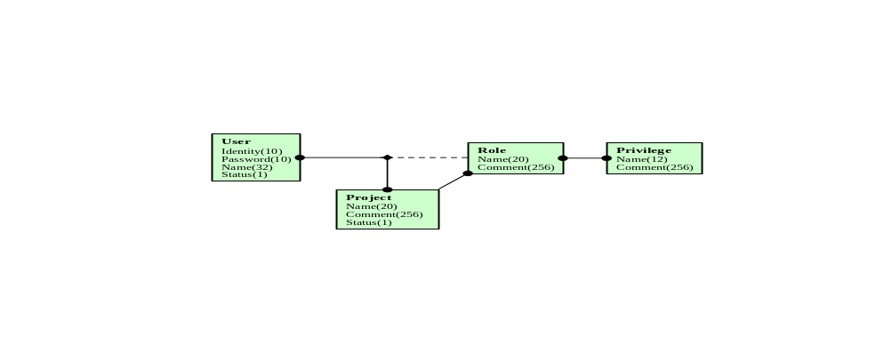
A user may or may not be assigned a role in a project. If he is assigned a role, he is said to be a member of the project. A user can have different roles in different projects, but the he can not have more than one role in a project. It is possible, though, for several project members to have the same role.

A project has a set of roles assigned to it. Each role is local to a project and defines a set of privileges. Several roles can share the same privilege.

Project
Attribute | Type | Description
Name | Text[20] | Name of the project.  Must be unique within the system.
Comment | Text[256] | Project description.
Status | Text[1] | Status for the project. ”E” means enabled and ”D” means disabled. Users can only login on projects that are enabled.

Almost all information in the system is ”owned” by projects, directly or indirectly. Other part models in this section further describe this.

A change history is not kept for the object.

User
Attribute | Type | Description
Identity | Text[10] | Login identity for user, e.g. ”ANNY”.  Must be unique within the system.
Password | Text[10] | User password
Name | Text[32] | Full name for user, e.g. ”Anders Nyberg”
Status | Text[1] | Status for the user. ”E” means enabled and ”D” means disabled. Only enabled users can login to the system.

There exists a special user SYSTEM which is the administrator of the whole system. The SYSTEM user has its own user interface, as described in section 4.3. Users and projects can only be created by SYSTEM.

A change history is not kept for the object.

Role
Attribute | Type | Description
Name | Text[20] | Name of the role, e.g. ”Project leader”.  Must be unique within the project.
Comment | Text[256] | Role description.

At least one of the roles in a project should include the privilege PROJECT_ADM, and at least one of the project members should be assigned this role.

A change history is not kept for the object.

Privilege
Attribute | Type | Description
Name | Text[12] | Short name of the privilege, e.g. ”PROJECT_ADM”
Comment | Text[256] | Privilege description.

Almost all privileges correspond directly to operations in the user interface. It is only possible for a user to do a certain user interface operation if the corresponding privilege is a member of the set of privileges defined by the users project role.

A change history is not kept for the object.

The special privilege PROJECT_ADM should be assigned to a limited number of project members. It allows a user to create and update project roles, to add and delete project members and to reassign roles for project members.

There exist about 40 different privileges in the system. The complete set of privileges is described in section 4.5.

Part model 2: Species
The following part model shows how species and closely related objects are modeled in the system.
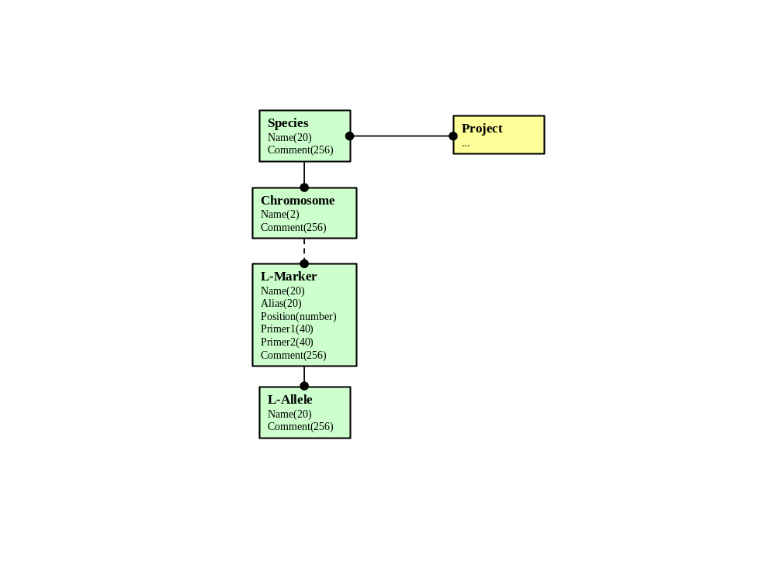
A species has a set of chromosomes. Each chromosome has a set of library markers
(L-Marker) and each library marker has a set of library alleles (L-Allele).

A project works with one or many species. Species are shared by many projects.

Species, chromosomes, library markers and alleles are not ”owned” by projects, and cannot be created by projects. They can only be created by the system administratror, that is the user SYSTEM.

Species
Attribute | Type | Description
Name | Text[20] | Name of species, e.g. ”HUMAN”.  Must be unique within the system.
Comment | Text[256] | Species description.

Species represents biological species, i.e. humans, chickens or rats.

A change history is not kept for the object.

Chromosome
Attribute | Type | Description
Name | Text[2] | Name of chromosome, e.g. ”22” or ”X”.  Must be unique within the species.
Comment | Text[256] | Chromosome description.

The chromosome object actually represents a chromosome type. Humans has 46 chromosomes but only 24 chromosome types: 1, 2, .. , 22, X and Y.

A change history is not kept for the object.

L-Marker
Attribute | Type | Description
Name | Text[20] | Marker name.  Must be unique within the species.
Alias | Text[20] | Marker alias.
Position | Number | Genetic chromosome position for the marker, may be NULL.
Primer1 | Text[40] | Primer 1, may be NULL
Primer2 | Text[40] | Primer 2, may be NULL
Comment | Text[256] | Marker description

A library marker points to a locus on a certain chromosome. The DNA-sequence at the locus is polymorph and the different variants are called alleles.

A change history is not kept for the object.

A project cannot store genotypes for a library marker directly. The library marker must first be imported by the project. This is done by copying the definition, including library alleles, for the library marker to a marker local to the project.

L-Allele
Attribute | Type | Description
Name | Text[20] | Allele name or identity.  Must be unique within the library marker.
Comment | Text[256] | Allele description.

A library allele stores information about a specific allele, i.e. one of the possible variants of a DNA-sequence at a locus on a chromosome.

A change history is not kept for the object.

Part model 3: Sampling Units
The following part model shows how sampling units and closely related objects are modeled in the system.
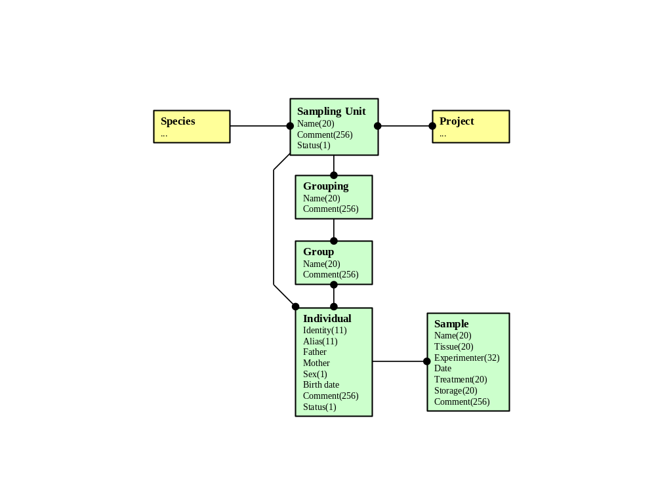
A sampling unit consists of a set of individuals, all of the same species. To each individual belongs a set of samples. A sampling unit can be shared by many projects. A project can work with many sampling units.

The set of individuals in a sampling unit can be structured by the help of groupings and groups. A sampling unit can have many groupings and each grouping can have many groups. A group can have many individuals as members and an individual can be a member of many groups.

Sampling Unit
Attribute | Type | Description
Name | Text[20] | Sampling unit name.  Must be unique within the system.
Comment | Text[256] | Sampling unit description.
Status | Tex[t1] | Status for the user. ”E” means enabled and ”D” means disabled. Projects can only work with enabled sampling units.

Sampling units are sets of individuals that are collected and processed together. Many information objects, i.e. genotypes and phenotypes, are ”owned” by sampling units.

A change history is kept for the object.

Individual
Attribute | Type | Description
Identity | Text[11] | Individual name.  Must be unique within the sampling unit.
Alias | Text[11] | Alias for individual, may be NULL  Must be unique within the sampling unit.
Father | Reference | Reference to father, may be NULL
Mother | Reference | Reference to mother, may be NULL
Sex | Text[1] | ”M” means male, ”F” means female and ”U” means unknown.
Birth_date | Date | Date of birth, may be NULL
Comment | Text[256] | Individual description.
Status | Tex[t1] | Status for the individual. ”E” means enabled and ”D” means disabled. Disabled individuals are treated as non-existent when data files are generated.

The object individual stores general information about an individual.

A change history is kept for the object.

Grouping
Attribute | Type | Description
Name | Text[20] | Grouping name.
Comment | Text[256] | Grouping description.

A grouping is used to name a set of groups belonging to some kind of genetically interesting grouping. Examples of such groupings are families and generations.

A change history is kept for the object.

Group
Attribute | Type | Description
Name | Text[20] | Group name.
Comment | Text[256] | Group description.

A group is used to model a set of individuals belonging to some kind of genetically interesting group. Examples of such groups are family FAM023 and generation F0, F1 or F2.

A change history is kept for the object.

Sample
Attribute | Type | Description
Name | Text[20] | Sample name.  Must be unique within the individual.
Tissue | Text[20] | Tissue type, may be NULL
Experimenter | Text[32] | Name of experimenter, may be NULL
Date | Date | Date of sample, may be NULL
Treatment | Text[20] | Sample treatment, may be NULL
Storage | Text[20] | Sample storage, e.g. freeze, may be NULL
Comment | Text[256] | Sample comment.

The object sample stores information about tissue samples from individuals.

A change history is kept for the object.

Part model 4: Phenotypes
The following part model shows how phenotypes and closely related objects are modeled in the system.
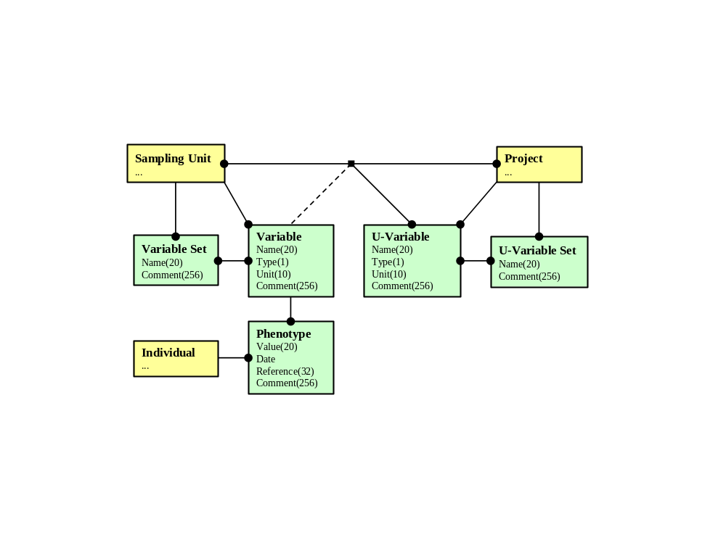
A sampling unit has a local set of variables and a local set of variable sets. A variable set defines a set of variables and a variable can be a member of many different variable sets. A phenotype can be stored for one variable and one individual.

A project has a local set of unified variables (U-Variable) and a local set of unified variable sets (U-Variable Set). A unified variable set defines a set of unified variables and a unified variable can be a member of many unified variable sets.

The relation between project, sampling unit, u-variable and variable defines a unique mapping from a unified variable to a variable for a sampling unit in a project. Many unified variables can be mapped to the same variable, though. In other words, given a project and a sampling unit, we can go from a unified variable to a variable in a unique way, but not the other way around. The need for this relation is described in section 3.4.4. The relation can be imported from file. The format is described in section 5.3.5.

Variable
Attribute | Type | Description
Name | Text[20] | Variable name, e.g. ”WEIGHT”.  Must be unique within the sampling unit.
Type | Text[1] | Variable type. ”E” means enumeration and ”N” means number.
Unit | Text[10] | Measuring unit, e.g. ”kg” or ”cm”
Comment | Text[256] | Variable description.

Variables represent things you can ”observe” on individuals, i.e. weight or a certain illness. Variables must be defined in order to store phenotypes in the database.

A change history is kept for the object.

Variable Set
Attribute | Type | Description
Name | Text[20] | Variable set name.  Must be unique within the sampling unit.
Comment | Text[256] | Variable set name.

Variable sets are used for specifying which variables, and phenotypes, to include in data files, when the set of individuals comes from a single sampling unit.

A change history is kept for the object.

Phenotype
Attribute | Type | Description
Value | Text[20] | Observed value, e.g. ”145,35”
Date | Date | Date of observation, may be NULL
Reference | Text[32] | Reference to raw data for the observation, may be NULL
Comment | Text[256] | Phenotype comment.

Phenotypes store ”observations” of variables for individuals.

A change history is kept for the object.

U-Variable
Attribute | Type | Description
Name | Text[20] | Unified variable name, e.g. ”WEIGHT”.  Must be unique within project and species.
Comment | Text[256] | Unified variable description.

Unified variables are used to ”unify” variables in different sampling units. The following example explains the concept of variable unification.

Example: A project works with two sampling units, S1 and S2. Both units have their own local variables for weight. The variables are called ”Weight” in S1 and ”WGT” in S2. In order for the system to be able to treat the variables as the same variable, a local unified variable ”WEIGHT” is created by the project. ”WEIGHT” is linked to both ”Weight” and ”WGT” by the relation between project, sampling unit, unified variable and variable. The unified variable ”WEIGHT” can now be used to refer to the ”same type” of phenotype data in sampling unit S1 and S2.

Unified variables are needed in order to specify the content of generated data files with phenotype data from multiple sampling units. Phenotype data for one variable is typically written to a single column in such a data file. In the process of specifying the content of the file, a reference to a unified variable uniquely specifies the data that shall be written to one column, even if it comes from several sampling units.

Note that a variable can be related to several unified variables. Alternative ”unifications” can therefore exist concurrently in the system.

A change history is kept for the object.

U-Variable Set
Attribute | Type | Description
Name | Text[20] | Unified variable set name.  Must be unique within the project.
Comment | Text[256] | Unified variable set name.

Unified variable sets are used for specifying which variables, and phenotypes, to include in data files, when the set of individuals comes from multiple sampling units.

A change history is kept for the object.

Part model 5: Genotypes
The following part model shows how genotypes and closely related objects are modeled in the system.
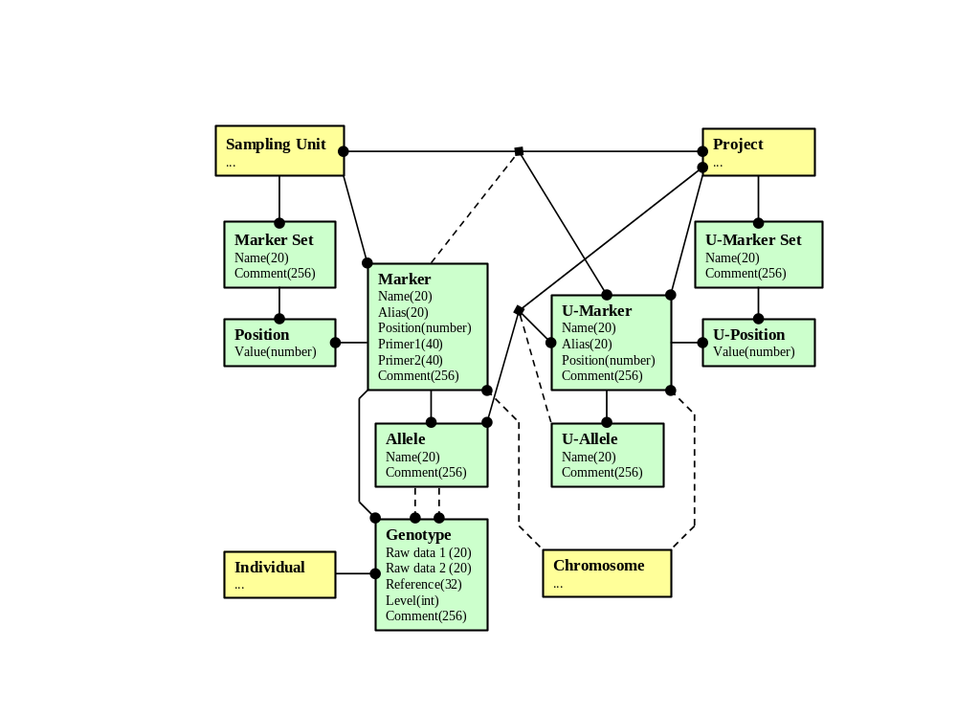
A sampling unit has a local set of markers and a local set of marker sets. A marker set defines a set of markers and a marker can be a member of many marker sets. A marker belongs to a chromosome and has a position in a marker set. A marker has a set of alleles. A genotype can be stored for one marker and one individual.

A project has a local set of unified markers (U-Marker) and a local set of unified marker sets (U-Marker Set). A unified marker set defines a set of unified markers and a unified marker can be a member of many unified marker sets. A unified marker belongs to a chromosome and has a unified position (U-position) in a unified marker set.

The relation between project, sampling unit, u-marker and marker exists for the same reasons as the corresponding relation for phenotypes.

The relation between project, sampling unit, allele and u-allele defines a unique mapping from an allele to a unified allele for a unified marker in a project.

The need for the above two relations is described in section 3.5.6 and 3.5.7. The relations can be imported from file. The format is described in section 5.2.5.

Marker
Attribute | Type | Description
Name | Text[20] | Marker name.  Must be unique within the sampling unit.
Alias | Text[20] | Marker alias.  Must be unique within the sampling unit.
Position | Number | Genetic chromosome position for the marker, may be NULL.
Primer1 | Text[40] | Primer 1, may be NULL
Primer2 | Text[40] | Primer 2, may be NULL
Comment | Text[256] | Marker description.

A marker points to a locus on a specific chromosome. Markers must be defined in order to store genotypes in the database.

The attribute position can be used for calculation of genetic distances, refer to the position attribute value.

A change history is kept for the object.

Allele
Attribute | Type | Description
Name | Text[20] | Allele name.  Must be unique within the marker.
Comment | Text[256] | Allele description.

An allele stores information about a specific allele, i.e. one of the possible variants of a DNA-sequence at a locus identified by a marker.

A change history is kept for the object.

Genotype
Attribute | Type | Description
Raw data 1 | Text[20] | Raw data value for allele 1
Raw data 2 | Text[20] | Raw data value for allele 2
Reference | Text[32] | Reference to raw data, e.g. micro film or gel
Comment | Text[256] | Comment
Level | Integer(0..9) | Confidence or security level. 0 means low and 9 means high confidence.

The object stores the observed pair of alleles for an individual at the locus defined by a marker.

The level attribute stores the confidence, or security, level of the data. Project members have different privileges corresponding to different security levels. A user with privileges for level 5 can only create or update genotype data with level 5 or less. A project leader, with level 9 privileges, can lock data by setting the level to 9.

A change history is kept for the object.

Marker Set
Attribute | Type | Description
Name | Text[20] | Marker set name.  Must be unique within the sampling unit.
Comment | Text[256] | Marker set description.

Marker sets are used for specifying which markers, and genotypes, to include in data files, when the set of individuals comes from a single sampling unit.

A change history is kept for the object.

Position
Attribute | Type | Description
Value | Number | The genetic position (in cM) for the marker in this marker set, may be NULL

Position implements the relation between marker sets and markers. It also stores a value that is used for the genetic ordering of markers on the same chromosome.

The value can even be used for the calculation of genetic distances between marker ”neighbors”. The distance between two marker ”neighbors” on the same chromosome is calculated as their difference in position.

If value is null, the marker attribute position is used for calculation of genetic distances.

A change history is kept for the object.

U-Marker
Attribute | Type | Description
Name | Text[20] | Unified marker name.  Must be unique within the project.
Alias | Text[20] | Unified marker alias.  Must be unique within the project.
Position | Number | Genetic chromosome position for the marker, may be NULL.
Comment | Text[256] | Unified marker description.

Unified markers are used to ”unify” markers in different sampling units. Unified markers exist for analogous reasons as unified variables, refer to section 3.4.4.

The attribute position can be used for calculation of genetic distances, refer to the unified position attribute value.

A change history is kept for the object.

U-Allele
Attribute | Type | Description
Name | Text[20] | Unified allele name.  Must be unique within the unified marker.
Comment | Text[256] | Unified allele description.

Unified alleles are used to ”unify” alleles for markers in different sampling units. Unified alleles are needed, in addition to unified markers, in order to specify the content of data files with genotype data from multiple sampling units. The system uses unified alleles and the relation between project, sampling unit, allele and unified allele in order to translate the name of an allele to the name of a unified allele, when genotype data is written to the file.

Note that a unified allele can be related to several alleles. Alternative ”unifications” can therefore exist concurrently in the system.

A change history is kept for the object.

Unified Marker Set
Attribute | Type | Description
Name | Text[20] | Unified marker set name.  Must be unique within project and species.
Comment | Text[256] | Unified marker set description.

Unified marker sets are used for specifying which markers, and genotypes, to include in data files, when the set of individuals comes from multiple sampling units.

A change history is kept for the object.

U-Position
Attribute | Type | Description
Value | Number | The genetic position (in cM) for the unified marker in this unified marker set.

Unified position implements the relation between unified marker sets and unified markers, analogous to position for marker sets and markers.

If value is null, the unified marker attribute position is used for calculation of genetic distances.

A change history is kept for the object.

Part model 6: Analyses
The following part model shows how file generations and closely related objects are modeled in the system.
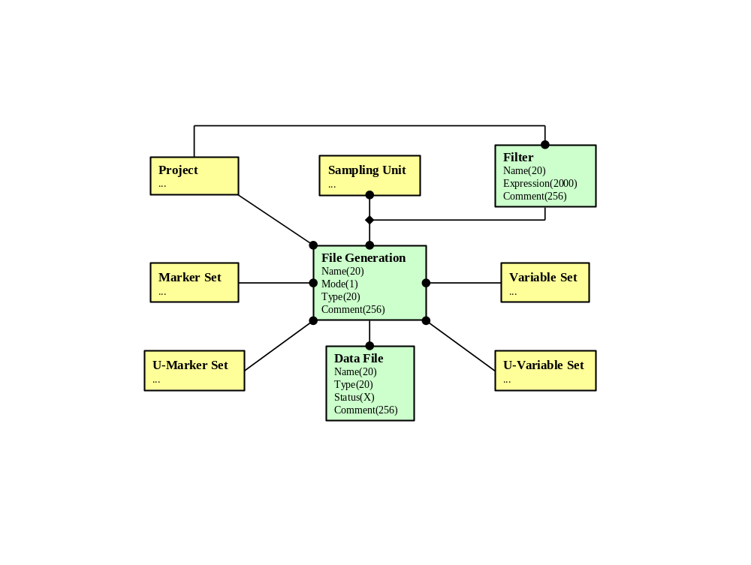
File generations are created by projects from one or several sampling units. Different filters can be used to select individuals from each participating sampling unit.

The file generation consists of a set of data files in various formats, e.g. LINKAGE.

The phenotype and genotype data retrieved for a data file is specified by a variable set and a marker set if there is only one participating sampling unit.

The phenotype and genotype data retrieved for a data file is specified by a unified variable set and a unified marker set if there is several participating sampling units.

File Generation
Attribute | Type | Description
Name | Text[20] | File generation name.  Must be unique within the project.
Mode | Text[1] | General mode. ”S” means single and ”M” means multiple sampling units.
Type | Text[20] | File generation type, e.g. ”LINKAGE” or ”CRIMAP”
Comment | Text[256] | File generation description.

A file generation is a name for a set of data files generated from one or several sampling units.

A change history is kept for the object.

Data File
Attribute | Type | Description
Name | Text[20] | Data file name.
Type | Text[20] | Data file type, e.g. ”LINKAGE” or ”README”.
Status | Text[8} | Data file status, e.g. ”37” means 37% is currently generated, and ”ERROR” means an error occurred during file generation.
Comment | Text[256] | Data file description.

One or several data files are generated as the result of file generation.

A change history is kept for the object.

Filter
Attribute | Type | Description
Name | Text[20] | Filter name, e.g. ”ALL MALE”.
Expression | Text[2000] | Logical expression written in GQL.
Comment | Text[256] | Filter description.

A filter is a boolean expression used for advanced selection of individuals from sampling units. During the selection process, the expression is evaluated for each individual in a sampling unit. The individuals, for which the expression evaluates to true, are said to be selected by the filter.

A filter expression is specified in the language GQL, refer to section 4.4.

A change history is kept for the object.

User interface

Login Procedure
The first step of the login procedure is independent of projects. The user only types in user identity and password. If the identity exists and the password is correct, the user is allowed access to the system user interface.

If the user logs in as a normal user, i.e. all users except the system administrator, he is given access to the functionality described in section 4.2. The user then has to select a project, among those for which he is a member, before he can do anything else. The type of access given to the user depends on his project role.

If the user logs in as the system administrator, i.e. the user SYSTEM, he is given full access to the functionality described in section 4.3.

Normal User Functionality
This section describes all forms belonging to the user interface for normal users, i.e. project members. The forms are grouped in five different categories, corresponding to five of the six part models described in section 3:

- Project Administration (part model 1: projects and users)
- Sampling Unit Administration (part model 3: sampling units)
- Phenotype Administration (part model 4: phenotypes)
- Genotype Administration (part model 5: genotypes)
- Analysis Administration (part model 6: analyses)

The objects in ”part model 2: species” are not project dependent and are therefore administrated by the system administrator.

The access to the functionality in the normal user interface is controlled by the user privileges defined by a users role. Note that this section generally describes the forms without discussing the privileges that are needed in order to use the forms.

The exceptions are forms that require the PROJECT_ADM or PROJECT_STA privileges. Refer to section 4.5 for a complete description of all privileges.

Project Administration

Set Project
The form is used for setting the active project, i.e. the project the user wants to work with. Only projects for which the user has a defined role can be chosen.

After login this form is displayed and it is mandatory for the user to select a project before he can go to another form. The active project can also be changed without a new login.

List Project Members
The form displays a list of all project members. The following attributes are displayed for the users in the list:

- Identity
- Name
- Role
- Status

The following operations are accessible from the form:

- Create a new project member, i.e. assign a role to an already existing user
- Update the role for a project member
- Delete a project member

The PROJECT_ADM privilege is required by the form.

Project Statistics
The form displays various project statistics, such as:

- number of users
- number of sampling units
- number of individuals
- number of variables
- number of phenotypes
- number of markers
- number of genotypes

The PROJECT_STA privilege is required by the form.

List Roles
The form displays a list of all roles matching a combination of the following search fields:

- Privilege: choice of one or all (matching a privilege linked to the role)

The following attributes are displayed for the roles in the list:

- Name
- Comment

The following operations are accessible from the form:

- Create a new role
- Update a role, including its set of privileges
- Delete a role

The PROJECT_ADM privilege is required by the form.

Import Role
The form is used to import a new role, including its definition, from a file. The file format is described in section 5.6.1.

The PROJECT_ADM privilege is required by the form.

Session Options
The form is used to set various parameters which controls the behavior of user interface during the current session. The following parameters can be set:

- How to display null values, i.e. missing values.
- The maximum number of rows displayed in forms.
- Date format, i.e. how to display dates

Sampling Unit Administration

List Sampling Units
The form displays a list of all sampling units matching a combination of the following search fields:

- Species: choice of one
- Status: choice of enabled or disabled

The following attributes are displayed for the sampling units in the list:

- Name
- Beginning of comment
- Number of individuals
- User who made the last update
- Date of last update

The following operations are accessible from the form:

- View details for a sampling unit, e.g. all attributes and change history
- Create a new sampling unit
- Update a sampling unit
- Delete a sampling unit
- Check a sampling unit

When a sampling unit which is linked to other projects is deleted, it is only unlinked from the project.

When a sampling unit is checked a report of all individuals with some of the following errors is produced:

- Parent does not exist
- Parent is of wrong sex
- Parent birth date is wrong

List Groupings
The form displays a list of all groupings matching a combination of the following search fields:

- Sampling unit: choice of one

The following attributes are displayed for the groupings in the list:

- Name
- Beginning of comment
- Number of groups
- User who made the last update
- Date of last update

The following operations are accessible from the form:

- View details for a grouping, including change history.
- Create a new grouping.
- Update a grouping.
- Delete a grouping.
- Copy a grouping, i.e. copy the groups to a new grouping.

Import Groupings
The form is used to import a new grouping, including groups and their members, from file. The file format is described in section 5.1.2.

List Groups
The form displays a list of all groups matching a combination of the following search fields:

- Sampling unit: choice of one
- Groupings: choice of one

The following attributes are displayed for the groups in the list:

- Name
- Beginning of comment
- Number of individuals
- User who made the last update
- Date of last update

The following operations are accessible from the form:

- View details for a group, including change history.
- Create a new group.
- Update a group.
- Delete a group.
- Copy a group to a new group in an existing grouping.

Group Membership
The form is used to add or delete group members.

List Individuals
The form displays a list of all individuals matching a combination of the following search fields:

- Sampling unit: choice of one
- Identity: search pattern with wildcards
- Alias: search pattern with wildcards
- Sex: choice of male, female, unknown or all
- Birth date from: date
- Birth date to: date
- Father identity: search pattern with wildcards
- Mother identity: search pattern with wildcards
- Status: choice of enabled or disabled

The following attributes are displayed for the individuals in the list:

- Identity
- Alias
- Sex
- Birth date
- Father identity
- Mother identity
- User who made the last update
- Date of last update

The following operations are accessible from the form:

- View details for an individual, including change history.
- Create a new individual.
- Update an individual.
- Delete an individual.

Import Individuals
The form is used to import individuals to a sampling unit, including groupings and groups from file. The file format is described in section 5.1.1.

The file can contain both new and existing individuals. Existing individuals are updated and new individuals are created.

List Samples
The form displays a list of all samples matching a combination of the following search fields:

- Sampling unit: choice of one
- Individual identity: search pattern with wildcards
- Sample name: search pattern with wildcards
- Sample tissue: search pattern with wildcards
- Sample storage: search pattern with wildcards

The following attributes are displayed for the samples in the list:

- Individual identity
- Sample name
- Sample tissue
- Sample storage
- User who made the last update
- Date of last update

The following operations are accessible from the form:

- View details for a sample, including change history.
- Create a new sample.
- Update a sample.
- Delete a sample.

Import Samples
The form is used to import samples to individuals in a sampling unit from file. The file format is described in section 5.1.3.

Existing samples are updated and new samples are created.

Phenotype Administration

List Variables
The form displays a list of all variables matching a combination of the following search fields:

- Sampling unit: choice of one
- Name: search pattern with wildcards
- Type: choice of enumeration, number or both
- Unit: search pattern with wildcards

The following attributes are displayed for the variables in the list:

- Name
- Type
- Unit
- Beginning of comment
- User who made the last update
- Date of last update

The following operations are accessible from the form:

- View details for a variable, including change history.
- Create a new variable.
- Update a variable.
- Delete a variable.

Import Variables
The form is used to import new variables from a file. The file format is described in section 5.3.1.

List Variable Sets
The form displays a list of all variable sets matching a combination of the following search fields:

- Sampling unit: choice of one
- Name: search pattern with wildcards
- Variable: search pattern with wildcards (matching a variable in the set)

The following attributes are displayed for the variable sets in the list:

- Name
- Beginning of comment
- User who made the last update
- Date of last update

The following operations are accessible from the form:

- View details for a variable set, including change history.
- Create a new variable set.
- Update a variable set.
- Delete a variable set.

Variable Set Membership
The form is used to add or delete variable set members.

Import Variable Sets
The form is used to import a new variable set from file. The file format is described in section 5.3.2.

List U-Variables
The form displays a list of all unified variables matching a combination of the following search fields:

- Name: search pattern with wildcards
- Type: choice of enumeration, number or both
- Unit: search pattern with wildcards

The following attributes are displayed for the unified variables in the list:

- Name
- Type
- Unit
- Beginning of comment
- User who made the last update
- Date of last update

The following operations are accessible from the form:

- View details for a unified variable, including change history.
- Create a new unified variable.
- Update a unified variable.
- Delete a unified variable.

Map U-Variables
The form is used to map unified variables to variables in sampling units.

Import U-Variables
The form is used to import new unified variables from a file. The file format is the same as for variables, and is described in section 5.3.1.

Import U-Variable mappings
The form is used to import mappings from unified variables to variables. The file format is described in section 5.3.5.

List U-Variable Sets
The form displays a list of all unified variable sets matching a combination of the following search fields:

- Sampling unit: choice of one
- Name: search pattern with wildcards
- Unified variable: search pattern with wildcards (matching a unified variable in the set)

The following attributes are displayed for the unified variable sets in the list:

- Name
- Beginning of comment
- User who made the last update
- Date of last update

The following operations are accessible from the form:

- View details for a unified variable set, including change history.
- Create a new unified variable set.
- Update a unified variable set.
- Delete a unified variable set.

U-Variable Set Membership
The form is used to add or delete unified variable set members.

Import U-Variable Sets
The form is used to import a new unified variable set from a file. The file format is the same as for variables sets, and is described in section 5.3.2.

List Phenotypes
The form displays a list of all phenotypes matching a combination of the following search fields:

- Sampling unit: choice of one
- Individual identity: choice of one or all
- Variable: choice of one or all

The following attributes are displayed for the phenotypes in the list:

- Individual identity
- Variable
- Value
- User who made the last update
- Date of last update

The following operations are accessible from the form:

- View details for a phenotype, including change history.
- Create a new phenotype.
- Update a phenotype.
- Delete a phenotype.

Import Phenotypes
The form is used to import phenotypes from file. The possible file formats are described in section 5.3.3 and 5.3.4.

There are three modes: ”create new”, ”update existing” and ”create or update”.

In mode ”create new” only new phenotypes are created because old phenotypes are not allowed in the file.

In mode ”update existing” only old phenotypes are updated because new phenotypes are not allowed in the file.

In mode ”create or update” both new phenotypes are created and old phenotypes are updated because both are allowed in the file.

Phenotype Status
The form is used to display status for phenotypes, i.e. display how many of the possible phenotypes for a specific filter and a specific variable set are stored in the database. The status is displayed for each variable in the variable set.

Genotype Administration

List Markers
The form displays a list of all markers matching a combination of the following search fields:

- Sampling unit: choice of one
- Chromosome: choice of one or all

The following attributes are displayed for the markers in the list:

- Chromosome
- Name
- Beginning of comment
- User who made the last update
- Date of last update

The following operations are accessible from the form:

- View details for a marker, including alleles and change history.
- Create a new marker.
- Update a marker.
- Delete a marker.
- View details for an allele, including change history.
- Create a new allele.
- Update an allele.
- Delete an allele.

Import Markers
The form is used to import new markers, including alleles from a file. The file format is described in section 5.2.1.

Import Library Markers
The form is used to import new markers, including alleles from the library, i.e. the set of library markers.

List Marker Sets
The form displays a list of all marker sets matching a combination of the following search fields:

- Sampling unit: choice of one
- Name: search pattern with wildcards
- Comment: search pattern with wildcards
- Marker: search pattern with wildcards (matching a marker in the set)

The following attributes are displayed for the marker sets in the list:

- Name
- Beginning of comment
- User who made the last update
- Date of last update

The following operations are accessible from the form:

- View details for a marker set, including change history.
- Create a new marker set.
- Update a marker set.
- Delete a marker set.

Marker Set Membership
The form is used to add or delete marker set members.

Marker Set Positions
The form is used to view and edit the genetic positions for the markers in a marker set.

Import Marker Sets
The form is used to import a new marker set, including positions, from a file. The file format is described in section 5.2.2

List U-Markers
The form displays a list of all unified markers matching a combination of the following search fields:

- Chromosome: choice of one or all

The following attributes are displayed for the unified marker sets in the list:

- Name
- Beginning of comment
- User who made the last update
- Date of last update

The following operations are accessible from the form:

- View details for a unified variable set, including unified alleles and change history.
- Create a new unified variable set.
- Update a unified variable set.
- Delete a unified variable set.
- View details for a unified allele, including change history.
- Create a new unified allele.
- Update a unified allele.
- Delete a unified allele.

Map U-Markers
The form is used to map unified markers to markers in sampling units, and alleles to unified alleles.

Import U-Markers
The form is used to import new unified markers from a file. The file format is the same as for markers, and is described in section 5.2.1.

Import U-Marker mappings
The form is used to import mappings from unified markers to markers, and alleles to unified alleles. The file format is described in section 5.2.5.

List U-Marker Sets
The form displays a list of all unified marker sets matching a combination of the following search fields:

- Name: search pattern with wildcards
- Comment: search pattern with wildcards
- Unified variable: search pattern with wildcards (matching a unified marker in the set)

The following attributes are displayed for the unified marker sets in the list:

- Name
- Comment (max 50 characters)
- User who made the last update
- Date of last update

The following operations are accessible from the form:

- View details for a unified marker set, including change history.
- Create a new unified marker set.
- Update a unified marker set.
- Delete a unified marker set.

U-Marker Set Membership
The form is used to add or delete unified marker set members.

U-Marker Set Positions
The form is used to view and edit the genetic positions for the unified markers in a unified marker set.

Import U-Marker Sets
The form is used to import a new unified marker set from a file. The file format is the same as for marker sets and is described in section 5.2.2.

List Genotypes
The form displays a list of all genotypes matching a combination of the following search fields:

- Sampling unit: choice of one
- Individual identity: choice of one or all
- Chromosome: choice of one or all
- Marker: choice of one or all
- Allele 1: search pattern with wildcards
- Allele 2: search pattern with wildcards
- Reference: search pattern with wildcards

It is not possible to select both all identities and all markers simultaneously.

The following attributes are displayed for the genotypes in the list:

- Individual identity
- Allele 1
- Allele 2
- Reference
- Level
- User who made the last update
- Date of last update

The following operations are accessible from the form:

- View details for a genotype, including change history.
- Create a new genotype.
- Update a genotype.
- Delete a genotype.

Update Level for a Set of Genotypes
The form is used to update the level attribute for a set of genotypes simultaneously. The genotypes matching a combination of the following search fields defines the set:

- Sampling unit: choice of one
- Individual identity: choice of one or all
- Chromosome: choice of one or all
- Marker: choice of one or all
- Level: choice of one or all
- User: choice of one or all
- Date From: date
- Date To: date

Import Genotypes
The form is used to import genotypes from file. The file formats are described in section 5.2.3 and 5.2.4.

There are three modes: ”create new” , ”update existing” and ”create or update”.

In mode ”create new” only new genotypes are created because old genotypes are not allowed in the file.

In mode ”update existing” only old genotypes are updated because new genotypes are not allowed in the file.

In mode ”create or update” both new genotypes are created and old genotypes are updated because both are allowed in the file.

The level attribute is not included in the file. The user therefore gives the level before import starts.

In modes where existing genotypes are updated, a list of all genotypes with differences between old and new data is displayed. The user can decide by marking each genotype individually, if it shall be updated or not. Buttons that mark all or clear all marks exists. Finally the user can decide if he wants to perform the update or cancel the whole data import.

The list of differences must be printable.

Genotype Status
The form is used to display status for genotypes, i.e. display how many of the possible genotypes for a specific filter and a specific marker set are stored in the database. The status is displayed for each marker in the marker set.

Inheritance Check
This form is used to perform an inheritance check for individuals in a sampling unit. In the form, the user selects a sampling unit, a number of markers, a grouping and one or more groups within the selected grouping. When the check is started, an inheritance check is performed on the individuals in the selected sampling unit with the given markers.

The check results in three files:
- Error file, contains all erroneous genotypes
- Correcting file, contains all erroneous genotypes in a file format which can be directly imported into the system
- Segregation file, contains the frequency of the genotypes of the father and the mother among the children

Analyses Administration

List Filters
The form displays a list of all filters matching a combination of the following search fields:

- Name: search pattern with wildcards
- Expression: search pattern with wildcards

The following attributes are displayed for the filters in the list:

- Name
- Beginning of expression
- User who made the last update
- Date of last update

The following operations are accessible from the form:

- View details for a filter, including change history.
- Create a new filter.
- Edit and test a filter.
- Delete a filter.

List File Generations
The form displays a list of all file generations, generated or being generated, matching a combination of the following search fields:

- Name: search pattern with wildcards
- Mode: choice of single, multiple or both
- Type: choice of one or all
- Status: choice of generated, being generated, error, or all

The following attributes are displayed for the file generations in the list:

- Name
- Mode
- Type
- Status
- Size
- User who made the last update
- Date of last update

The following operations are accessible from the form:

- View details for an analysis and/or download results.
- Update a file generation.
- Delete a file generations.

Start File Generation
The form, and its sub forms, is used to create a file generation, including data files.

In order to generate an file generation the user first has to specify the mode of the generation, i.e. if one or several sampling units are to be analyzed.

In single mode, only one sampling unit can be analyzed. The user has to specify the following:

- A sampling unit
- A filter
- A marker set
- A variable Set
- An analysis type, e.g. CRIMAP

In multiple mode, several sampling units can be analyzed. The user has to specify the following:

- A set of sampling units
- A filter for each sampling unit
- A unified marker set
- A unified variable set
- An analysis type, e.g. CRIMAP

The following file generation types can be generated, in both single and multiple modes:

- General Table Format
- Linkage (3 variants: before makeped, after makeped and without disease locus)
- Crimap
- Mapmaker

The file formats corresponding to the analyses file types that are described in section 5.4.

System Administrator Functionality
This section describes all forms belonging to the user interface for the system administrator. The forms are grouped in two different categories, corresponding to two of the six part models described in section 3:

- Project Administration (part model 1: projects and users)
- Species Administration (part model 2: species)

Project Administration

Edit Projects
The form displays a list of all projects matching a combination of the following search fields:

- Name: search pattern with wildcards
- Species: choice of one or all (matching a species linked to the project)
- Sampling Unit: choice of one or all (matching a sampling unit linked to the project)
- User: choice of one or all (matching a project member)
- Status: choice of enabled or disabled

The following attributes are displayed for the projects in the list:

- Name
- Comment

The following operations are accessible from the form:

- Creation and update of projects.
- Linking and unlinking of species to projects.
- Linking and unlinking of sampling units to projects.
- Linking and unlinking of users, i.e. project members.
- Creation, update and deletion of roles.
- File import of roles. The file format is described in section 5.6.1.

The form is typically used by the system administrator to create and initialize new projects.

Project Statistics
The form gives the system administrator an overview of all projects, and their size in terms of:

- number of users
- number of species
- number of sampling units
- etc

List Users
The form displays a list of all users matching a combination of the following search fields:

- Identity: search pattern with wildcards
- Name: search pattern with wildcards

The following attributes are displayed for the users in the list:

- Identity
- Name

The following operations are accessible from the form:

- View password for a user.
- Create a new user.
- Update a user.
- Delete a user.

Species Administration

List Species
The form displays a list of all species in the system. The following attributes are displayed for the species in the list:

- Name
- Beginning of comment
- Date of last update

The following operations are accessible from the form:

- View details for a species, including chromosomes.
- Create a new species.
- Update a species.
- Delete a species.
- View details for a chromosome.
- Create a new chromosome.
- Update a chromosome.
- Delete a chromosome.
- Import chromosomes from file. The file format is described in section 5.5.1.

List L-Markers
The form displays a list of all library markers matching a combination of the following search fields:

- Species: choice of one
- Chromosome: choice of one or all
- Name: search pattern with wildcards

The following attributes are displayed for the markers in the list:

- Chromosome
- Name
- Beginning of comment
- Date of last update

The following operations are accessible from the form:

- View details for a library marker, including library alleles.
- Create a new library marker.
- Update a library marker.
- Delete a library marker.
- View details for a library allele.
- Create a new library allele.
- Update a library allele.
- Delete a library allele.

Import L-Markers
The form is used to import new library markers, including library alleles from a file. The file format is the same as for markers, and is described in section 5.2.1.

Import Project Markers
The form is used to import new library markers, from projects.

Genetic Query Language - GQL
The formal language for writing filter expressions is called GQL, Genetic Query Language.

Standard Oracle expressions are a sub set of GQL. A GQL expression can therefore be made up by combinations of parentheses, logical and numerical operators, standard functions and user-defined functions. The only limitation is the length: 2000 characters.

In addition to the above, a GQL expression may consist of the following special terms:
- Individual attributes, e.g. sex or birth date
- Genotype attributes, e.g. allele or raw data for allele
- Phenotype attributes, e.g. value or date
- Set membership, e.g. grouping or group.

Individual attributes are referenced with the prefix: ”I.” As shown by the following example:

- I.SEX

Genotype attributes are referenced with the prefix: ”G.” As shown by the following example:

- G.MA001.A1 (allele 1 for marker MA001)

Phenotype attributes are referenced with the prefix: ”P.” As shown by the following example:

- P.EYE_COLOR (value of the phenotype eye color).

Set membership is referenced with the prefix S. As shown by the following examples:

- S. GENERATIONS (member of the grouping GENERATIONS)
- S.GENERATIONS.F2 (member of group F2 in the grouping GENERATIONS).

All the above constructs refer to attributes or membership for the individual under evaluation. It is possible though, to refer to attributes or membership for parents of the individual. This can be made by writing a sequence of M (for mother) and F (for father) after the first prefix, as shown in the following example:

- P.FM.EYE_COLOR (value of eye color for the individuals fathers mother).

User Privileges

General Privileges
Privilege | Gives a user right to
PROJECT_ADM | Add or delete project members  Add, delete or update project roles
PROJECT_STA | View project statistics

Sampling Unit Privileges
Privilege | Gives a user right to
SU_W | Create, update or delete sampling units  Check sampling units
SU_R | View sampling units
GRP_W | Create, copy, update or delete groupings and groups  Edit group membership
GRP_R | View groupings and groups  View group membership
IND_W | Create, update or delete individuals and samples
IND_R | View individuals and samples

Phenotype Privileges
Privilege | Gives a user right to
VAR_W | Create, update or delete variables
VAR_R | View variables
VARS_W | Create, update or delete variable sets  Edit variable set membership
VARS_R | View variable sets  View variable set membership
UVAR_W | Create, update or delete unified variables  Map unified variables
UVAR_R | View unified variables
UVARS_W | Create, update or delete unified variable sets  Edit unified variable set membership
UVARS_R | View unified variable sets  View unified variable set membership
PHENO_W | Create, update or delete phenotypes
PHENO_R | View phenotypes

Genotype Privileges
Privilege | Gives a user right to
MRK_W | Create, update or delete markers and alleles
MRK_R | View markers and alleles
LMRK_R | View and copy library markers and alleles
MRKS_W | Create, update or delete marker sets  Edit marker set membership and positions
MRKS_R | View marker sets  View marker set membership and positions
UMRK_W | Create, update or delete unified markers and alleles  Map unified markers and alleles
UMRK_R | View unified markers and alleles
UMRKS_W | Create, update or delete unified variable sets  Edit unified variable set membership and unified positions
UMRKS_R | View unified variable sets  View unified variable set membership and unified positions
GENO_W0 | Create, update or delete genotypes with level = 0
GENO_W1 | Create, update or delete genotypes with level <= 1
GENO_W2 | Create, update or delete genotypes with level <= 2
GENO_W3 | Create, update or delete genotypes with level <= 3
GENO_W4 | Create, update or delete genotypes with level <= 4
GENO_W5 | Create, update or delete genotypes with level <= 5
GENO_W6 | Create, update or delete genotypes with level <= 6
GENO_W7 | Create, update or delete genotypes with level <= 7
GENO_W8 | Create, update or delete genotypes with level <= 8
GENO_W9 | Create, update or delete genotypes with level <= 9
GENO_R | View genotypes

Only one of the privileges GENO_Wn (n=0..9) can be assigned to a role.

Analysis Privileges
Privilege | Gives a user right to
FLT_W | Create, update or delete filters
FLT_R | View filters
ANA_W | Create, update or delete file generations
ANA_R | View file generations and data files  Down load data files

File formats
This chapter describes all file formats that can be imported to and exported from the system. The import file formats are specially designed for this system and their structure are very similar. All these formats have the following three things in common:

File header row
All file formats start with a file header row which has the following format:
<object name>/<format name>/<version>/<field separator>
<object name> is the type of data in the file, e.g. INDIVIDUAL or PHENOTYPE.
<format name> is the type of file format, e.g. LIST or MATRIX.
<version> is the version number of the file format. At the moment only version 1 is supported, but this allows for multiple version support in the future.
<field separator> is the character used as field separator in the file. Note that the field separator is limited to only one character.
The following file header is an example of a file header for genotype files:
GENOTYPE/MATRIX/1/;

Comment rows
Comment rows can be put anywhere in the file except on the first two lines. A comment row always starts with the character # in the first column.
The following example shows a comment row:
# The following phenotypes where mesured by Vidar

Missing data
Missing data is written as nothing, i.e. no characters at all, not even a space character. In a genotype file should for instance missing alleles be written as nothing, and not as 0.

Sampling Unit Files

Individual File
The file format is used to import individuals to a sampling unit.

The file header has the following format:

INDIVIDUAL/LIST/<version>/<field separator>

The file continues with a table header row followed by one row for each individual. The table header looks as follows:

IDENTITY ALIAS FATHER MOTHER SEX BIRTH_DATE COMMENT [GROUPING…]

Note that there can be zero, one or several columns with groupings.

Each individual row contains the following fields:

- Identity
- Alias (possibly null)
- Father identity (possibly null)
- Mother identity (possibly null)
- Sex (possibly null)
- Birth date (possibly null)
- Comment (possibly null)
- Group name(s) (possibly null)

Note that there can be zero, one or several columns with group names.

Example:
INDIVIDUAL/LIST/1/
IDENTITY ALIAS FATHER MOTHER SEX BIRTH_DATE COMMENT GENERATIONS FAMILIES
# Parents
001 father M 1988-01-10 F0 A
002 mother F 1998-07-16 F0 A
# Children
003 boy1 001 002 M 1999-07-10 F1 A
004 boy2 001 002 M 1999-07-10 F1 A
005 boy3 001 002 M 1999-07-10 F1 A
006 girl1 001 002 F 1999-07-10 F1 A
007 girl2 001 002 F 1999-07-10 F1 A

TAB is used as field separator in the above example.

Grouping File
The file format is used to import groupings to a sampling unit.

The file header has the following format:

GROUPING/LIST/<version>/<field separator>

The file continues with a table header row followed by one row for each individual. The table header exists in two variants:

LIDENTITY [GROUPING…]
ALIAS [GROUPING…]

Note that there can be one or several columns with groupings.

Each individual row contains the following fields:

- Individual identity or alias
- Group name(s) (possibly null)

Note that there can be one or several columns with group names.

Example:
GROUPING/LIST/1/;
IDENTITY;FAMILIES;FAMILIES2
001;F001;F001
002;;F002
003;F001;F001
004;;F001
005;F002;F002
006;F002;F002
007;F002;
008;F002;F002

; is used as field separator in the above example.

Sample File
The file format is used to import samples for individuals in a sampling unit.

The file header has the following format:

SAMPLE/LIST/<version>/<field separator>

The file continues with a table header row followed by one row for each sample. The table header exists in two variants:

IDENTITY NAME TISSUE EXPERIMENTER DATE TREATMENT STORAGE COMMENT
ALIAS NAME TISSUE EXPERIMENTER DATE TREATMENT STORAGE COMMENT

Each sample row contains the following fields:

- Individual identity or alias
- Name
- Tissue (possibly null)
- Experimenter (possibly null)
- Date (possibly null)
- Treatment (possibly null)
- Storage (possibly null)
- Comment (possibly null)

Example:
SAMPLE/LIST/1/
ALIAS NAME TISSUE EXPERIMENTER DATE TREATMENT STORAGE COMMENT
# father samples taken by Ingrid
father B1 BLOOD Vidar 1988-01-10 FX003:1
father H1 HAIR Leif 1998-07-16 FX003:2
# mother samples taken by Holger
mother B1 BLOOD Holger 1999-07-10 FY007:1
mother B2 BLOOD Holger 1999-07-10 FY007:2
mother B3 BLOOD Holger 1999-07-10 FY007:3
mother B4 BLOOD Holger 1999-07-10 FY007:4
mother B5 BLOOD Holger 1999-07-10 FY007:5
mother B6 BLOOD Holger 1999-07-10 FY007:6
mother B7 BLOOD Holger 1999-07-10 FY007:7
mother H1 HAIR Leif 1998-07-16 FY007:8

TAB is used as field separator in the above example.

Genotype Files

Marker File
The file format is used to import markers, unified markers or library markers, including their allele definitions.

The file header has one of the following three formats depending on which type of markers the file contains:

MARKER/LIST/<version>/<field separator>
UMARKER/LIST/<version>/<field separator>
LMARKER/LIST/<version>/<field separator>

The file continues with a table header row followed by one row for each marker. The header row exists in two variants:

CHROMOSOME MARKER ALIAS POSITION PRIMER1 PRIMER2 COMMENT [ALLELEn …]
CHROMOSOME MARKER ALIAS POSITION PRIMER1 PRIMER2 COMMENT [ALLELEn ALLELEnCOMM …]

Note that there can be zero, one or several columns with alleles and allele comments.

Each marker row contains the following fields:

- Chromosome name
- Name
- Alias (possibly null)
- Position (possibly null)
- Primer1 (possibly null)
- Primer2 (possibly null)
- Comment (possibly null)
- Allele name(s) (possibly null)
- Allele comment(s) (possibly null)

Note that there can be zero, one or several columns with allele names and allele comments.

Example 1:
MARKER/LIST/1/
CHROMOSOME MARKER ALIAS POSITION PRIMER1 PRIMER2 COMMENT ALLELE1 ALLELE2
1 MS0101 M1 0.8 ACCGT AGGCT 1 2
1 MS0102 M2 1.5 AGTTCG TCGGTA 1
2 MS0201 0.5 1 2

Example 2:
LMARKER/LIST/1/
CHROMOSOME MARKER ALIAS POSITION PRIMER1 PRIMER2 COMMENT ALLELE1 ALLELE1COMM
1 MS0101 M1 0.8 ACCAA CGGTG 1
1 MS0102 M2 1.5 ACAGG TTGTA 1 causes low BP
2 MS0201 0.5 1

TAB is used as field separator in the above examples.

Marker Set File
The file format is used to import marker sets or unified marker sets.

The file header has one of the following two formats depending on which type of marker set the file contains:

MARKERSET/LIST/<version>/<field separator>
UMARKERSET/LIST/<version>/<field separator>

The file continues with a table header row followed by one row for each marker in the set. The table header looks as follows:

MARKER POSITION

Each marker row contains the following fields:

- Marker name
- Marker position in the set (possibly null)

Example:
MARKERSET/LIST/1/
MARKER POSITION
MS0101 0.0
MS0102 1.5
MS0201 0.0

TAB is used as field separator in the above example.

Genotype List File
The file format is used to import a list of genotypes for individuals in a sampling unit.

The file header has the following format:

GENOTYPE/LIST/<version>/<field separator>

The file continues with a header row followed by one row for each genotype. The header row exists in two variants:

IDENTITY MARKER ALLELE1 ALLELE2 RAW1 RAW2 REFERENCE COMMENT
ALIAS MARKER ALLELE1 ALLELE2 RAW1 RAW2 REFERENCE COMMENT

Each genotype row contains the following fields:

- Individual identity or alias
- Marker name
- Allele 1 (possibly null)
- Allele 2 (possibly null)
- Raw data for allele 1 (possibly null)
- Raw data for allele 2 (possibly null)
- Reference (possibly null)
- Comment (possibly null)

Example 1:
GENOTYPE/LIST/1/
IDENTITY MARKER ALLELE1 ALLELE2 RAW1 RAW2 REFERENCE COMMENT
001 MS0101 1 1 135.1 135.3 GEL29
001 MS0102 1 2 135.1 143.9
001 MS0201 2 3 GEL32 Missing raw data

Example 2:
GENOTYPE/LIST/1/
ALIAS MARKER ALLELE1 ALLELE2 RAW1 RAW2 REFERENCE COMMENT
father MS0101 1 1 135.1 135.3 GEL29
father MS0102 1 2 135.1 143.9
father MS0201 2 3 GEL32 Missing raw data

TAB is used as field separator in the above examples.

Genotype Matrix File
The file format is used to import a matrix of genotypes for individuals in a sampling unit.

The file header has the following format:

GENOTYPE/MATRIX/<version>/<field separator>

The file continues with a table header row followed by one row for each individual. The header row exists in two variants:

IDENTITY [MARKER…]
ALIAS [MARKER…]

Note that there can be one or several columns with markers.

Each row in the data part contains the following fields:

- Individual identity or alias
- Allele 1 for marker n (possibly null)
- Allele 2 for marker n (possibly null)

Note that there can be one or several pair of columns with alleles.

Example 1:
GENOTYPE/MATRIX/1/
IDENTITY MS0101 MS0102 MS0201
# parents…
001 1 1 2 4 2 2
002 1 2 1 2 3
# children…
003 2 2 3 4 4

Example 2:
GENOTYPE/MATRIX/1/
ALIAS MS0101 MS0102 MS0201
# parents…
father 1 1 2 4 2 2
mother 1 2 1 2 3
# children…
son 2 2 3 4 4

TAB is used as field separator in the above examples.

Unified Marker Mapping File
The file format is used to import marker mappings for unified markers.

The file header has the following format:

UMARKER/MAPPING/<version>/<field separator>

The file continues with several sections, where each section contains a complete mapping for a unified marker. A section consists of two header rows followed by one row for each unified allele. The header rows looks as follows:

MAPPING [SAMPLING UNIT …]
U-MARKER [MARKER …]

The first header row contains the following fields:

- The keyword MAPPING
- Sampling unit(s) for which mappings exists

The second header row contains the following fields:

- Unified marker
- Mapped marker(s) in the sampling unit(s) on the first header row

Each unified allele row then contains the following fields:

- Unified allele
- Mapped allele for marker in sampling unit (possibly null)

Example:
UMARKER/MAPPING/1/
MAPPING SU001 SU002 SU003 SU004
M001 MS0101 MS0101 M001 MS0101
1 1 1 a 2
2 2 3 b 1
3 3 2 c 3
4 4 4 4
MAPPING SU001 SU002 SU003
M002 MS0303 MS0201 MX1
1 1 1 1
2 2 2 2
3
4 4
5 3 3 5

TAB is used as field separator in the above example.

Examples of how the file is interpreted:
- The third row tells us that the unified marker M001 (column 1) is mapped to the marker MS0101 in sampling unit SU002 (column 3).
- The fifth row tells us that the allele 3 for the marker MS0101 in sampling unit SU002 (column 3) is mapped to the unified allele 2 for the unified marker M001 (column 1).

Phenotype Files

Variable File
The file format is used to import variables or unified variables.

The file header has one of the following two formats depending on which type of variables the file contains:

VARIABLE/LIST/<version>/<field separator>
UVARIABLE/LIST/<version>/<field separator>

The file continues with a table header row followed by one row for each variable. The header row looks as follows:

VARIABLE TYPE UNIT COMMENT

Each variable row contains the following fields:

- Name
- Type, i.e. N or E.
- Unit (possibly null)
- Comment (possibly null)

Example:
VARIABLE/LIST/1/
VARIABLE TYPE UNIT COMMENT
WEIGHT N kg
HEIGHT N cm
DIABETES E Y or N

TAB is used as field separator in the above example.

Variable Set File
The file format is used to import variable sets or unified variable sets.

The file header has one of the following two formats depending on which type of variable set the file contains:

VARIABLESET/LIST/<version>/<field separator>
UVARIABLESET/LIST/<version>/<field separator>

The file continues with a header row followed by one row for each variable in the set. The header row always looks like this:

VARIABLE

Each variable row contains the following field:

- Variable name

Example:
VARIABLESET/LIST/1/
VARIABLE
WEIGHT
HEIGHT
DIABETES

TAB is used as field separator in the above example.

Phenotype List File
The file format is used to import a list of phenotypes for individuals in a sampling unit.

The file header has the following format:

PHENOTYPE/LIST/<version>/<field separator>

The file continues with a header row followed by one row for each phenotype. The header row exists in two variants:

IDENTITY VARIABLE VALUE DATE REFERENCE COMMENT
ALIAS VARIABLE VALUE DATE REFERENCE COMMENT

Each phenotype row contains the following fields:

- Individual identity or alias
- Variable name
- Value (possibly null)
- Date (possibly null)
- Reference (possibly null)
- Comment (possibly null)

Example 1:
PHENOTYPE/LIST/1/
IDENTITY VARIABLE VALUE DATE REFERENCE COMMENT
001 WEIGHT 80 2000-11-03 The father
001 HEIGHT 182 2000-11-03
002 WEIGHT 87 2000-11-03

Example 2:
PHENOTYPE/LIST/1/
ALIAS VARIABLE VALUE DATE REFERENCE COMMENT
father WEIGHT 80 2000-11-03 The father
father HEIGHT 182 2000-11-03
mother WEIGHT 87 2000-11-03

TAB is used as field separator in the above examples.

Phenotype Matrix File
The file format is used to import a matrix of phenotypes for individuals in a sampling unit.

The file header has the following format:

PHENOTYPE/MATRIX/<version>/<field separator>

The file continues with a table header row followed by one row for each individual. The header row exists in two variants:

IDENTITY [VARIABLE…]
ALIAS [VARIABLE…]

Note that there can be one or several columns with variables.

Each individual row contains the following fields:

- Individual identity or alias
- Phenotype value(s)

Note that there can be one or several phenotypes values.

Example 1:
PHENOTYPE/MATRIX/1/
IDENTITY WEIGHT HEIGHT
001 80 182
002 87 191
003 174

Example 2:
PHENOTYPE/MATRIX/1/
ALIAS WEIGHT HEIGHT
father 80 182
mother 87 191

TAB is used as field separator in the above examples.

Unified Variable Mapping File
The file format is used to import variable mappings for unified variables.

The file header has the following format:

UVARIABLE/MAPPING/<version>/<field separator>

The file continues with a table header row followed by one row for each unified variable. The header row looks as follows:

MAPPING [SAMPLING UNIT …]

The header row contains the following fields:

- The keyword MAPPING
- Sampling unit(s) for which mappings exists

Each unified variable row then contains the following fields:

- Unified variable
- Mapped variable in sampling unit (possibly null)

Example:
UVARIABLE/MAPPING/1/
MAPPING SU001 SU002 SU003
Weight WEIGHT Weight WGT
Height Length LTH
Eye_color EYE_COLOR Eye_colour Eye_color

TAB is used as field separator in the above example.

Analysis Files

General Table Format
This format is used to export a TAB-delimited table of genotype and phenotype data for a set of individuals, which is defined by a filter. Two files are generated.

Data.txt
The file starts with a table header row followed by one row for each individual. The table header contains a combination of the following selectable fields.

- SU.NAME (if sampling unit is selected)
- IDENTITY (if identity is selected)
- ALIAS (if alias is selected)
- SEX (if sex is selected)
- FATHER (if father is selected)
- MOTHER (if mother is selected)
- BIRTH_DATE (if birth date is selected)
- <marker n>.A1 (if a marker set is specified)
- <marker n>.A2 (if a marker set is specified)
- <marker n>.R1 (if a marker set is specified and raw data is selected)
- <marker n>.R2 (if a marker set is specified and raw data is selected)
- <variable n> (if a variable set is selected)
- REF (if reference is selected)

Each individual row then contains the following fields:

- Sampling unit (if sampling unit is selected)
- Identity (if identity is selected)
- Alias (if alias is selected)
- Sex (if sex is selected)
- Father (if father is selected)
- Mother (if mother is selected)
- Birth date (if birth date is selected)
- Allele 1 for marker n (if a marker set is specified)
- Allele 2 for marker n (if a marker set is specified)
- Raw data for marker n (if a marker set is specified and raw data is selected
- Raw data for marker n (if a marker set is specified and raw data is selected
- Value for variable n (if a variable set is selected)
- Reference (if reference is selected)

Example:
IDENTITY SEX MS0101.A1 MS0101.A2 MS0102.A1 MS0102.A2 MS0201.A1 MS0201.A2 WEIGHT HEIGHT
001 M 1 1 1 2 4 4 80 182
002 F 2 2 1 1 2 3 87 191
003 F 2 3 1 1 2 3 84 187

Log.txt
The file contains export parameter information, warnings and errors.

LINKAGE input format
This format is used to export input files to the LINKAGE program for a set of individuals, which is specified by a filter and a family grouping. Four or five files are generated.

Data.txt
The file contains information about disease locus (if present), markers, their relative order and allele frequencies; refer to LINKAGE documentation for a more detailed description.

Pedigree.txt
This file contains information about families, individuals, genotypes and disease status (if present), refer to LINKAGE documentation for a more detailed description.

The LINKAGE program requires that all families, individuals and alleles are coded as positive integers. Because of this, the system has to map the names of all these entities to positive integers. This is done by the following rules:

- Families are simply mapped to positive integers regardless of their names.
- Individuals are simply mapped to positive integers regardless of their names.
- Alleles are mapped to positive integers so that their names are preserved if they can be interpreted as a positive numbers.
- Alleles with the name 0 are mapped to null, i.e. missing data.

Pedigree_makeped.txt
This file is a slightly transformed version of the pedigree file. The MAKEPED program does the transformation; refer to LINKAGE documentation for a more detailed description.

The generation of this file is optional.

Mapping.txt
The file contains information about all mappings of individuals and alleles.

Log.txt
The file contains export parameter information, warnings and errors.

CRIMAP input format
This format is used to export input files to the CRIMAP program for a set of individuals, which is specified by a filter and a family grouping. Output can be generated in two formats. Either two files plus one file for each chromosome are generated, OR two files plus one large file with all chromosomes are generated.

Chr<n>.gen
This file contains information about families, individuals, markers and genotypes, refer to CRIMAP documentation for a more detailed description.

Depending on the selection when generation starts, either one file is generated for each chromosome, or one large file will be generated. In the first case, the file chr7.gen will for example contain data for chromosome 7.

The CRIMAP program requires that all individuals and alleles are coded as positive integers. Because of this, the system has to map the names of all these entities to positive integers. This is done by the following rules:

- Individuals are simply mapped to positive integers, unless their names can be interpreted as integers.
- Alleles are mapped to positive integers so that their names are preserved if they can be interpreted as a positive numbers.
- Alleles with the name 0 are mapped to null, i.e. missing data.

Mapping.txt
The file contains information about all mappings of individuals and alleles.

Log.txt
The file contains export parameter information, warnings and errors.

MAPMAKER input format
This format is used to export input files to the MAPMAKER program for a set of individuals, which is specified by a filter. Three files are generated.

Gen_prep.txt
The file contains information about markers, refer to MAPMAKER documentation for a more detailed description.

Gen_raw.txt
The file contains information about individuals, genotypes and phenotypes, refer to MAPMAKER documentation for a more detailed description.

Log.txt
The file contains export parameter information, warnings and errors.

Species Files

Chromosome File
The file format is used to import chromosomes for species.

The file header has the following format:

CHROMOSOME/LIST/<version>/<field separator>

The file continues with a table header row followed by one row for each chromosome for the species. The table header looks like this:

CHROMOSOME COMMENT

The chromosome rows contains the following fields:

- Name
- Comment (possibly null)

Example:
CHROMOSOME/LIST/1/
CHROMOSOME COMMENT
# Human chromosomes
1
2
3
4 No 4
5
6
7
8
9
10
11
12
13
14
15
16
17
18
19
20
21
22
# Sex chromosomes…
X
Y Male chromosome

TAB is used as field separator in the above example.

Project Files

Role File
The file format is used to import privileges for a role.

The file header has the following format:

ROLE/LIST/<version>/<field separator>

The file continues with a table header row followed by one row for each privilege assigned to the role. The header row looks like this:

PRIVILEGE

Each privilege row contains the following field:

- Name

Example:
ROLE/LIST/1/
PRIVILEGE
PROJECT_ADM
PROJECT_STA
SU_W
SU_R

TAB is used as field separator in the above example.

Document Versions
Version | Date | Comment | Author
V1 | 2000-04-11 |  | ANNY
V2 | 2000-06-28 |  | ANNY
V3 | 2000-06-30 |  | ANNY
V4 | 2000-11-03 |  | ANNY
V5 | 2000-11-30 |  | ANNY
V6 | 2001-06-29 |  | ANNY
V7 | 2002-05-21 |  | FROB

